Things I like to do

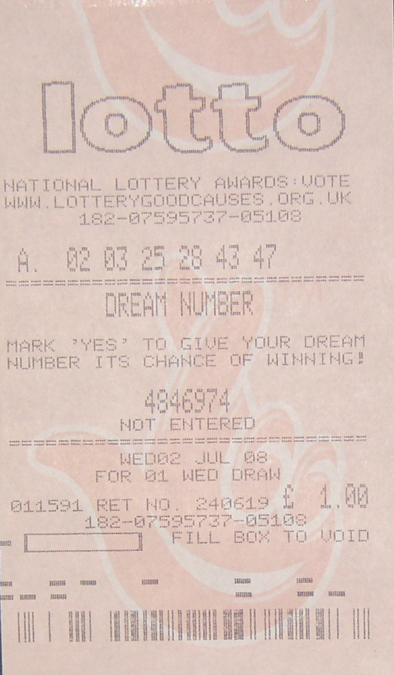

I like to do the lottery.
You never know I might win!



I enjoy going to the cafe

I like watching football on the TV
with my brother and his friends
